TOWN OF TRURO
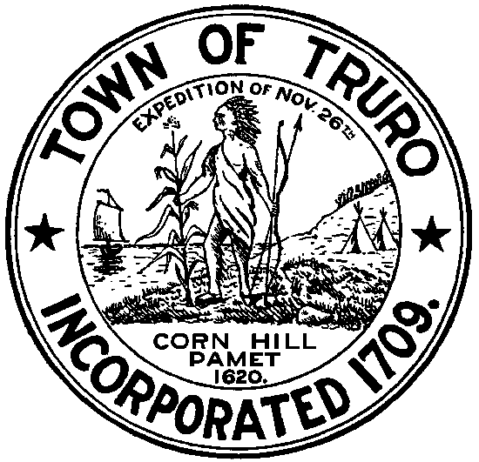
P.O. Box 2030, Truro, MA 02666
Tel: 508-349-7004, Extension: 10 or 24 Fax: 508-349-5505

WATER RESOURCES OVERSIGHT COMMITTEE AGENDA
THURSDAY, JANUARY 8, 2015 AT 4:00PM
SELECTMEN’S MEETING ROOM
TRURO TOWN HALL

- Finalize Phase 1 IWRMP

- Review progress of nitrate testing

- Begin Phase 2 planning IWRMP

