Climate Action Committee
Meeting Minutes
August 18, 2022

Members Present: Carol Harris, Chair, Rebecca Bruyn, Fred Gaechter
Guests: Lili Flanders and Georgia Neill
Town Liaison: Emily Harris

Topic | Discussion | Action
Minutes | Reviewed. Only change needed is the year of the minutes. With change made, Fred moved to approve, Carol seconded it and all approved the minutes for 8/4/22 | None at this time
Public Comment | None at this time
Climate Action Job Description | Much discussion re the position. Carol had sent other descriptions of town positions. All agreed that the title of the position would be best understood by our town if “climate action” manager/director is used vs. “sustainability” manager/director. This kind of position could possibly report to Town Manager or to both Emily and Jarrod. Will needs lots of discussion with town and then approval by the town at the next ATM. All agreed to review other town positions and email recommendations to Carol by 8/28/22 | Carol will resend positions and the draft she started. She will pull together everyone’s ideas to present at next meeting.
Letter to DOER | A formal letter to the DOER was presented by the EC to the SB last week, requesting the SB to support.  Due to the technical nature of the document, the complexity of the issue and therefore a lack of understanding of the content, the SB chose not to sign the document. The CAC and EC will sign it and submit to the DOER. More education needs to be provided to the SB members who will time to digest many of the issues that are front and center for the EC/CAC. | Ongoing
Truro Talks articles | Discussion re various ideas for the next few months; Preparing for the fall, Interviews with residents re purchasing EVs, building to Net Zero, the impact on the fishing industry, steps residents have taken on their own, moving from oil to electric, something about the specific impact that climate change has for the town of Truro.  Reviewed and approved Georgia’s September article with agreed changes. | Lili for October – moving from oil to electric  Fred for November – the dangers if we do nothing
Article 53 | This citizens petition, “establishing a net zero building standard for town funded building projects” that was passed at this year’s ATM has put the CAC, the EC and the SB in an odd position. All agreed that we will need to have something in place before next ATM. In the meantime, the DOER continues to ask for feedback re the stretch vs. stretchier building code. It was decided that the EC and the CAC need to meet with the SB re; the charge that the SB was given. That then makes this process formal for documentation purposes as well as taking steps to a possible resolution. | Carol to draft memo to the EC as a step towards moving the SB forward on Article 53
Mill Pond Road | Discussion re the proposed DPW actions to address the Mill Pond Road area. All agreed it would be best if Jarrod could attend a CAC meeting to discuss options. | Carol to reach out to Jarrod
Info tables | Discussed the response of the table at the Transfer Station last week. Enjoying working with the Cape Light Compact. The resident’s responses vary which is to be expected. Happy to have a presence out in the community. Just need a banner.  Dates for September, October, November are set for the Community Center and Library. We can continue to go to Transfer Station as well. | Carol to order banner for the table.
Shifting our focus, a bit | Discussion re how to get the residents involved. Rebecca mentioned she ran a monthly eco team from her home around 2009 to support one another in small behavioral changes and learning about how to read the electric bill for example. It’s time to shift some of our focus to getting residents engaged. Discussed starting up a monthly support group at the library, for example. | More to come.
Next meeting | September 1 at 10:30

Respectfully submitted,
Rebecca Bruyn

To: Truro Select Board
From: Climate Action Committee ?and Energy Committee?
Date: month/day/year
Topic: Clarification on Article 53 Charge

Article 53, as amended and approved at the 2022 Truro Town Meeting, states:
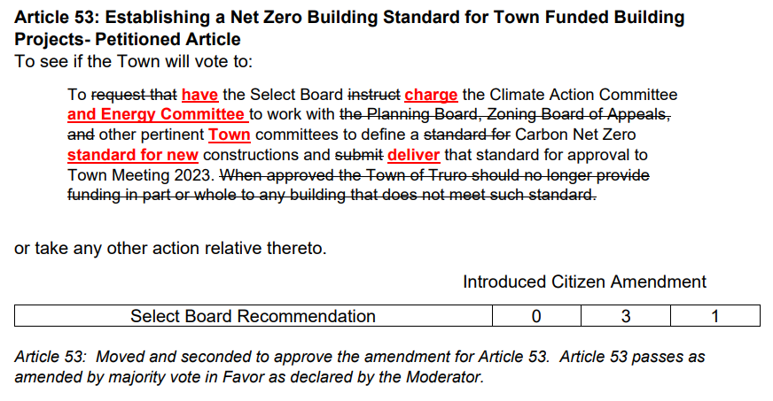
In order to form an appropriate response to Article 53, the Climate Action Committee (CAC) and the Energy Committee (EC), request clarification on the following points.
- What is a ‘town-funded’ building? Does this include buildings funded by grant money? For example, how does this relate to the Clover Leaf and Walsh properties a new DPW?
- What does ‘new construction” include: only new construction from the ground up? Complete additions to existing buildings? Upgrades to existing buildings?
- If the town provides land but not the construction, does Article 53 still apply?
The CAC and EC will use the Select Board’s responses to address Article 53.

Job Title: Climate Action Coordinator
Reports to: Health and Conservation Agent and/or DPW Director

Position Purpose:
Responsible for developing and implementing policies and actions to address the ways in which the town and residents can prevent further climate change and the specific impact of climate change in Truro and for communication and liaison with state and local climate agencies, boards and committees, residents, municipal staff, and business owners.
Supervision:
Supervision Scope: Performs routine functions under specific instructions from supervisor with some independent judgement.
Supervision Received: Works under the direction of the ?Health/Conservation Agent and/or Department of Public Works Director?
Supervision Given: None
Job Environment:
Work is generally performed in a moderate noise environment under general office conditions with some interruptions from the general public. Field work is conducted as needed outdoors with exposure to various weather conditions. Evening and weekend work as events require.
Operates computer equipment, printer, facsimile machine, telephone, copier, and all other standard office equipment; research using proper on-line sources; uses word processing, presentation, email, and spreadsheet software.
Interacts with municipal staff, boards and committees, residents, business owners, state and county organizations, and climate-related organizations.
Essential Functions:
The essential functions or duties listed below are intended to illustrate the various types of work that may be performed. The omission of specific statements of duties does not exclude them from the position if the work is similar, related or a logical assignment to the position. Reasonable accommodations may be made to enable individuals with disabilities to perform the essential functions.
- Work with and attend all meetings of the Climate Action Committee and the Energy Committee? to address climate change.
- Communication: develop and deliver information and actions about climate change impacts to a variety of audiences such as town employees, residents, and businesses.
- Data Analysis: identify financial, health, and commercial impact of climate change on Truro, and be able to create graphs to display potential improvements over time.
- Develop actions/responses for the municipality, boards and committees, residents, and businesses to minimize Truro’s carbon footprint.
- Identify and develop responses to the town’s vulnerabilities (health, economic, etc.).
- Draft policies.
- Collaborate with state and county agencies, Cape Light Compact, and local organizations.
- Research and respond to grant opportunities for addressing climate change.
Recommended Minimum Qualifications:
Education, Training, and Experience:
- Training and experience in the impacts of climate change
- Listening to and effectively communicating with a variety of constituents
- Researching grants and developing grant applications
Special Requirements: Strong written and oral communication skills; at a minimum a Bachelor’s Degree in something…..
Knowledge, Ability, and Skills:
- Knowledge: awareness of and/or willingness to learn about the impact of climate change, green building/LEEDs, and conservation.

- Ability: engage with a variety of constituents, keep up to date with state and local climate policies, continuously learn about advances in addressing the impacts climate change; collaborative approach to work.

- Skills: Researching and responding to grants; strong communication skills, including presentation and writing; community engagement and relationship building; able to partner and collaborate with various local and regional stakeholders.

Mini Splits: A Cleaner Energy Heating Alternative

As the days cool and we head deeper into fall, you may be testing your electric baseboard heating system, making sure your furnace is topped up with oil, or checking on your propane or natural gas supplies. But there’s a cleaner alternative to heating your home: mini splits, or air-source heat pumps. These heating and cooling systems run on electricity, are highly efficient and produce significantly less greenhouse gas emissions than baseboard, oil, gas or propane heating.
Mini splits not only reduce reliance on fossil fuels, such as oil (good news for our fragile Outer Cape environment), but cost less to run than baseboard or propane heating, so you can feel good about using cleaner energy, even as you save money.
There are both state and federal incentives that make installing mini splits even more cost-effective. You can get more information about those, as well as financing possibilities at: https://goclean.masscec.com/benefits-savings/
If you have solar panels on your home, or are thinking of installing them, they could offset part or all of the electrical costs of an air-source heat pump system. If you aren’t able to install solar panels, community solar could offer a good alternative to lowering the electrical cost of mini split heating and cooling. You can learn more about what community solar is, as well as find programs available to you, at: https://goclean.masscec.com/resources/#community-solar
One of the advantages of a mini split heating and cooling system is that it can be installed without duct work (making it an ideal upgrade for older homes). You can also choose which rooms you wish to heat or cool, according to your needs, further reducing heating and cooling costs. Most mini splits feature a “dry” mode, which reduces humidity. During sticky days, sometimes simply reducing the humidity in your home is enough to make it more comfortable. Another advantage to air-source pump systems is how quiet they are; unlike most air conditioning compressors, the outdoor unit of a mini split system makes very little noise.
It’s not too late to have efficient, clean energy mini splits installed in your home in time for winter. There are a number of Cape businesses that specialize in installing air-source heat pump systems, which can be found through an online search, or looking through HVAC listings in the phone book.
The process of installing an air-source heat pump system in your home includes mounting mini splits on the walls of the rooms you’d like heated and cooled, as well as placing one or more units outside (depending on the size of your home). An electrician–usually affiliated with the installer–will need to connect the new system to your electrical panel. The whole project can be completed in a few days.
Still confused about what exactly an air-source heat pump system is, or how it works? This short video from This Old House, offers a dynamic demonstration: https://goclean.masscec.com/clean-energy-solutions/air-source-heat-pumps/
[Offer a suggestion for reading?]

Truro’s Potential Climate Change Vulnerabilities
Although Truro is a small portion of the global Climate Change concern, there are many potentially adverse physical effects that will directly impact Truro and its citizens and, thereby, should necessitate individual and collective action. Some of these effects are near-term concerns while others are probably more long-term, i.e., affecting future Truro generations. The main causes and their potential local effects (in no order of priority) include, but might not be limited to:
- Cause: Sea-level Rise
Potential Effects - Damage to coastal, river, and tidal wetland areas from flooding and over-washing.
  - Flooded infrastructure – affected roadways will require elevation adjustments and temporary/permanent closings; utilities may require “hardening”.
  - Damage to buildings and properties at or abutting coastal and tidal areas.
  - Erosion of the coastal ecosystem.
  - Contamination of aquifer by salt water intrusion.
  - Damage to aquatic wild life habitats.
  - Compromised wells and septic systems.
  - Expanded flood zones with resultant insurance increases.
  - Decreased Tourism, due to above effects and, thereby, impacting the local economy and jobs.

- Cause: Climate Change

Potential Effects – Hotter temperatures, less seasonal precipitation, and increased storm activity/intensity.

  - Damages from increased storm activity – increased intensity of nor’easters and a greater potential for more and higher-category hurricanes reaching the warmer waters of Cape Cod resulting in physical and environmental damage, power outages, and increased insurance costs.
  - More frequent and longer drought events – restrictions on water usage.
  - Damage to upland wild life habitat – native species in danger, new invasive species dominate. Animal habitat, e.g., food, water, shelter, is in danger.
  - Impact on fishing and shellfish industry - certain species of fish moving north to colder waters and loss of shellfish not adaptable to warmer waters.
  - Public Health concerns – dangerous heat for outdoor workers and elderly without air conditioning; prolonged seasons for warn weather-related illnesses and potential introduction of illnesses not previously prevalent in the northeast.
  - Changes to farming season, need for crop adaptation, and damage to crops.
  - Upsetting the normal pattern of bird migration and summer habitation.
  - Less outdoor time in dangerous temperatures and increased utility bills for A/C.
The Truro Climate Action Committee was formed to research the potential impacts of climate change on Truro and to offer a Plan to mitigate effects where possible and adapt to those where mitigation might be too late or ineffective.
Questions or suggestions about addressing climate change? Interested in learning about joining the Committee or volunteering? Contact Truro’s Climate Action Committee at climateaction@truro-ma.gov

